

Department of

Electrical & Electronics Engineering

**Abdullah Gül University**

**Lab Experiment 3 Report – Frequency Division Multiplexing**

**EE3001 Telecommunication System Design Capsule**

**Submitted on: 12.03.2025**

**Submitted by: Serkan Kıyaklı**

|  |  |  |
| --- | --- | --- |
| **Group Number:** | 1 | |
| **Lab Partner:** | Aliye Birgül |  | |

**Lab Instructors: Müzeyyen Savaş**

**Grade: / 100**

**OBJECTIVE**

The aim of this experiment is to analyze frequency division multiplexing and crosstalk phenomena in a frequency-division multiplexing (FDM) technique and evaluate the impact of bandpass filter order on crosstalk performance. The study involves measuring the power of transmitted and received signals under different conditions and computing crosstalk measurements using logarithmic power ratios.

**BACKGROUND**

Frequency-division multiplexing (FDM) allows multiple signals to be transmitted simultaneously over a common medium by assigning them different frequency bands with. However, due to imperfect filtering, some signal leakage (crosstalk) occurs between channels "bleeding", affecting communication quality. The selectivity of bandpass filters plays a crucial role in minimizing this interference. Higher-order filters make sharper transitions and better isolation, reducing crosstalk, while lower-order filters provide wider transition bands, leading to greater signal leakage.

**DESIGN AND TEST PROCEDURES**

In the main lab, Tx and Rx sessions, which are constructed in prelab, will be evaluated. In Tx session, signal generators are set as follows,

|  |  |  |
| --- | --- | --- |
|  | Message 1 | Message 2 |
| Sub-Carrier Frequency | 500KHz | 510KHz |
| Tones | 100, 200 and 300 | 1KHz, 2KHz and 3KHz |

Table 1 – Required signals to be sent over TX1 port

To generate signals, created function is used (Prelab document). Then they added and sent to the Write Session on TX1 port.

Figure 1 – Tx session with Basic Multitone, Sub-function and signal processing part for Write function

Sampling rate, Carrier frequency and message length are set 2M, 915MHz and 200000, respectively. In Figure 1, sub-modulated signals are added. Then to eliminate quadrature term in the signal, an array is created with zeros and combines with main message with complex array. The real part of the array consists of only the message, however complex part includes just only zeros. After that the Tx session is executed.

Figure 2 – Unmodulated Signals, Brown waveform is message 1 and blue waveform is message 2

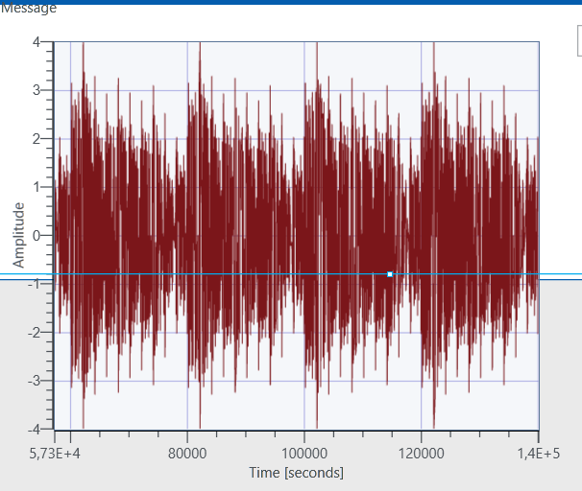

Figure 3 – Modulated message signal

In the Rx session part, the demodulation section is set up. It starts with two bandpass filters for two different messages are modulated with different frequencies. Each bandpass filter rejects one message and passes the message with desired passband bandwidth. As a result, messages are separated from each other. The cutoff frequency information of bandpass filters was discussed in prelab document. Next messages are sent to envelope detectors (which consist of two components: absolute value-as rectifier- and a low pass filter). Then messages are plotted on graphs (Figure 4 and Figure 5).

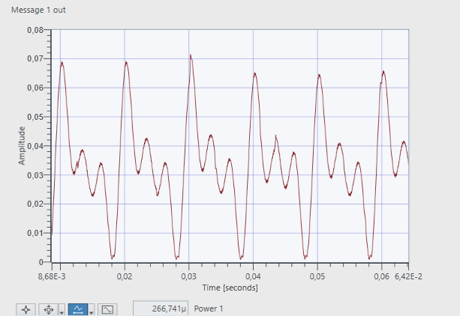

Figure 4 – Message 1 output in RX2 port

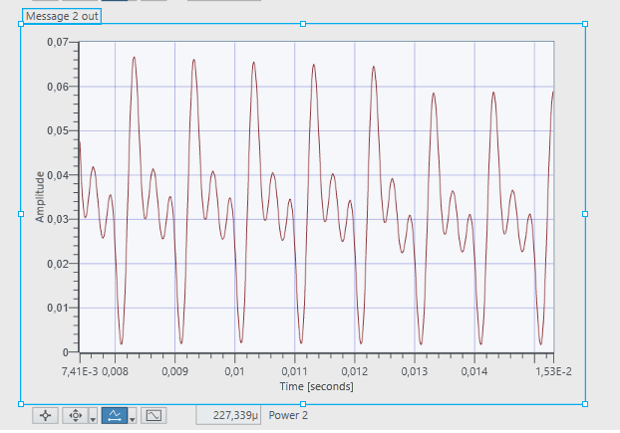

Figure 5 – Message 2 output in RX2 port

Furthermore, in RX setup to plot the FFT of messages a FFT block is used and here is the FFT of the messages (Figure 6 to Figure 10).

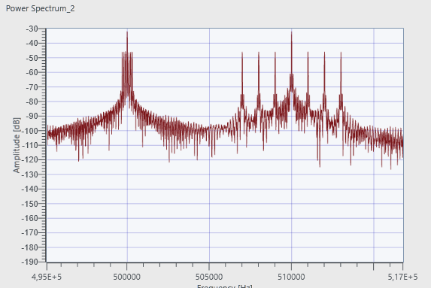

Figure 6 – FFT of the messages, it can be seen that their sub-carrier frequencies as expected with Table 1

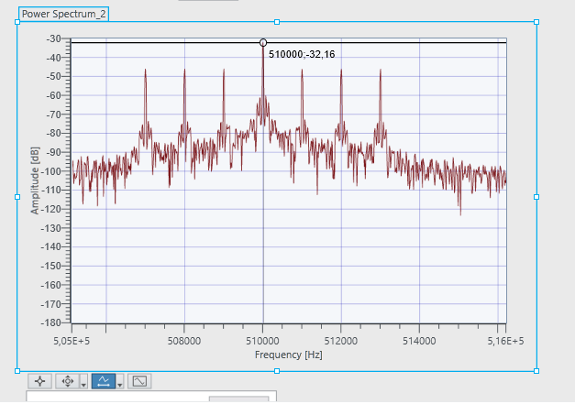

Figure 7 – Sub carrier frequency of 510KHz

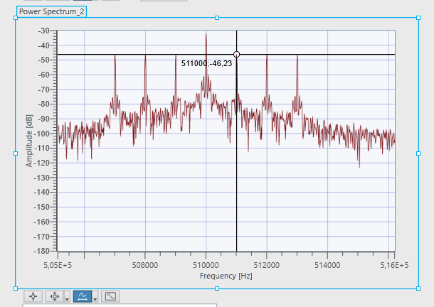

Figure 8 – For 510KHz, which is a carrier frequency for message 2. It can be seen that 1KHz, 2KHz and 3KHz signals are visible.

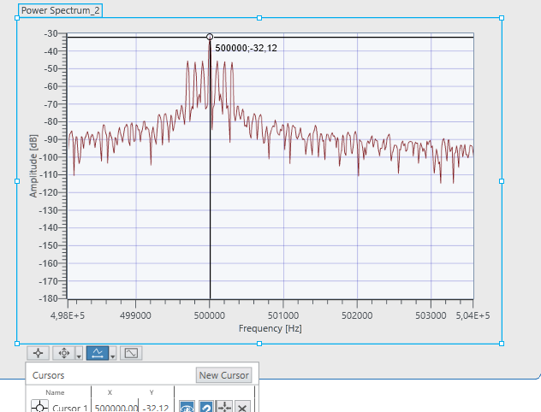

Figure 9 – Sub carrier frequency of 500KHz

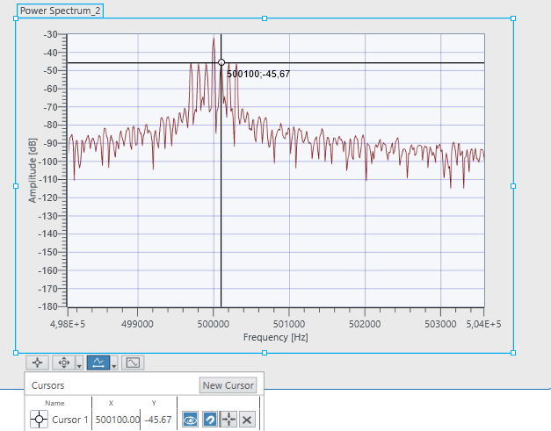

Figure 10 - For 50KHz, which is a carrier frequency for message 1. It can be seen that 100, 200 and 300Hz signals are visible.

Lastly there is part to understand and report the crosstalk phenomena. As an initial step, in Rx setup, an AC&DC Estimator is placed to calculate the powers of the signals. Then Tx is configured as sending same messages. Then in Rx side Sampling rate is set as 10MSa/s. Then initially powers are recorded. Here are the messages in RX panel and their powers,

Figure 11 – Graphs show that two identical messages and their powers: Power of Message 1 = 405.96u and Power of the Message 2 = 416.36u

Figure 12 – FFT of Message 1 and Message 2, centered around 500KHz and 510KHz respectively

To compute the crosstalk measurements, first in Tx session, message 2 is disconnected and message 1 only exists. Then power is recorded (Figure 13 to Figure).

Figure 13 – Message 2 disconnected

In Rx side,

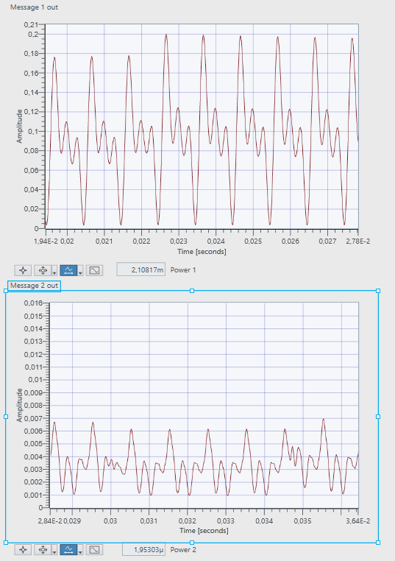

Figure 14 – Message 1 is exits on channel with power of 2.1m, however it “bleeds over” message 2 with power of 1.95u

Now the same process is done for message 2. Message 2 exists and message 1 is disconnected.

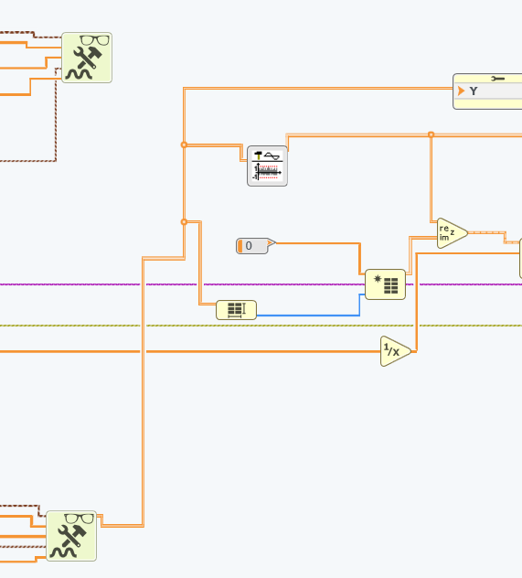

Figure 15 – Message 1 is disconnected

In the Rx side,

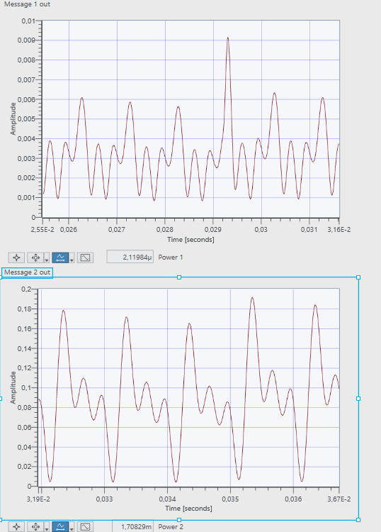

Figure 16 - Message 2 is exits on channel with power of 1.7m, however it “bleeds over” message 1 with power of 2.11u

The amount of crosstalk present in FDM depends on filter’s selectivity. Now the same process for Message 1 and Message 2 is done for bandpass filter’s order of 2, before it was 5.

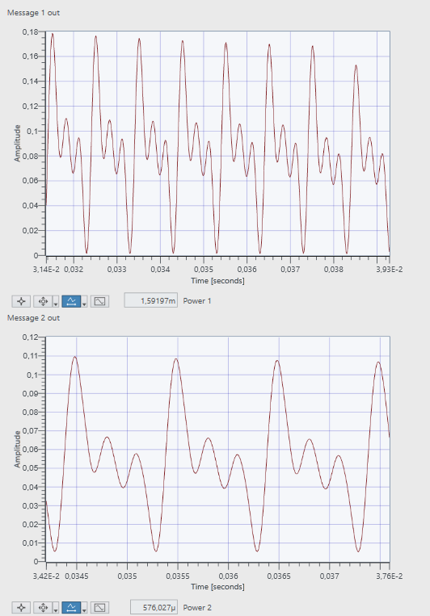

Figure 17 – Message 2 is disconnected. Message 1 exists on channel; however, it bleeds over channel two much more than previous results. Here the order of the bandpass filter is 2.

Figure 18 - Message 2 is disconnected. Message 1 exists on channel; however, it bleeds over channel two much more than previous results. Here the order of the bandpass filter is 2.

**RESULTS AND DISCUSSION**

To understand crosstalk phenomena quantitively, power values will be evaluated. Here is the table to summarize crosstalk experiments.

|  |  |  |  |  |
| --- | --- | --- | --- | --- |
| Filter order | Power of M1(P1A) | Power of M1 on M2(P2A) | Power of M2(P1B) | Power of M2 on M1(P2B) |
| 5 | 2.1m | 1.96u | 1.7m | 2.11u |
| 2 | 1.59m | 576.02u | 1.66m | 786.26u |

Table 2 – Power results to measure crosstalk

Crosstalk measurements can be calculated as follows,

Here is the result table to compare crosstalk for different bandpass orders.

|  |  |  |
| --- | --- | --- |
| Filter order |  |  |
| 5 | -0,320 | -0,9177 |
| 2 | -1,3512 | 0,1871 |

Table 3 – Crosstalk measurement for different filter orders.

From **Table 3**, the results indicate that decreasing the filter order from **5 to 2** leads to:

* decreasing from **-0.320 dB to -1.3512 dB**
* increasing from **-0.9177 dB to 0.1871 dB**

When the filter order decreases, XT₁₂ becomes more negative, meaning less power is coupled from M1 to M2. On the other hand, XT₂₁ increases, meaning more power is coupled from M2 to M1. This suggests that lower filter orders result in worse crosstalk performance, particularly in one direction.

**CONCLUSIONS**

The experiment demonstrated that crosstalk is significantly influenced by filter order. When the filter order decreased from 5 to 2, XT₁₂ became more negative, indicating reduced interference from Message 1 to Message 2. However, XT₂₁ increased, showing that more power from Message 2 bled into Message 1’s channel. These results confirm that lower filter orders result in worse crosstalk performance, addressing the great importance of using high-order filters in FDM systems to minimize interference.

**REFERENCES**

1. Black, Bruce A., Introduction to Communication Systems, Lab Based Learning with NI USRP and LabVIEW Communications
2. Kıyaklı, S., Birgül, A. Prelab 3 Report, Frequency Division Multiplexing